**LOCAL AREA ASSESSMENT**

4 Claygate Close, Hornchurch, RM12 4LU (London Borough of Havering)

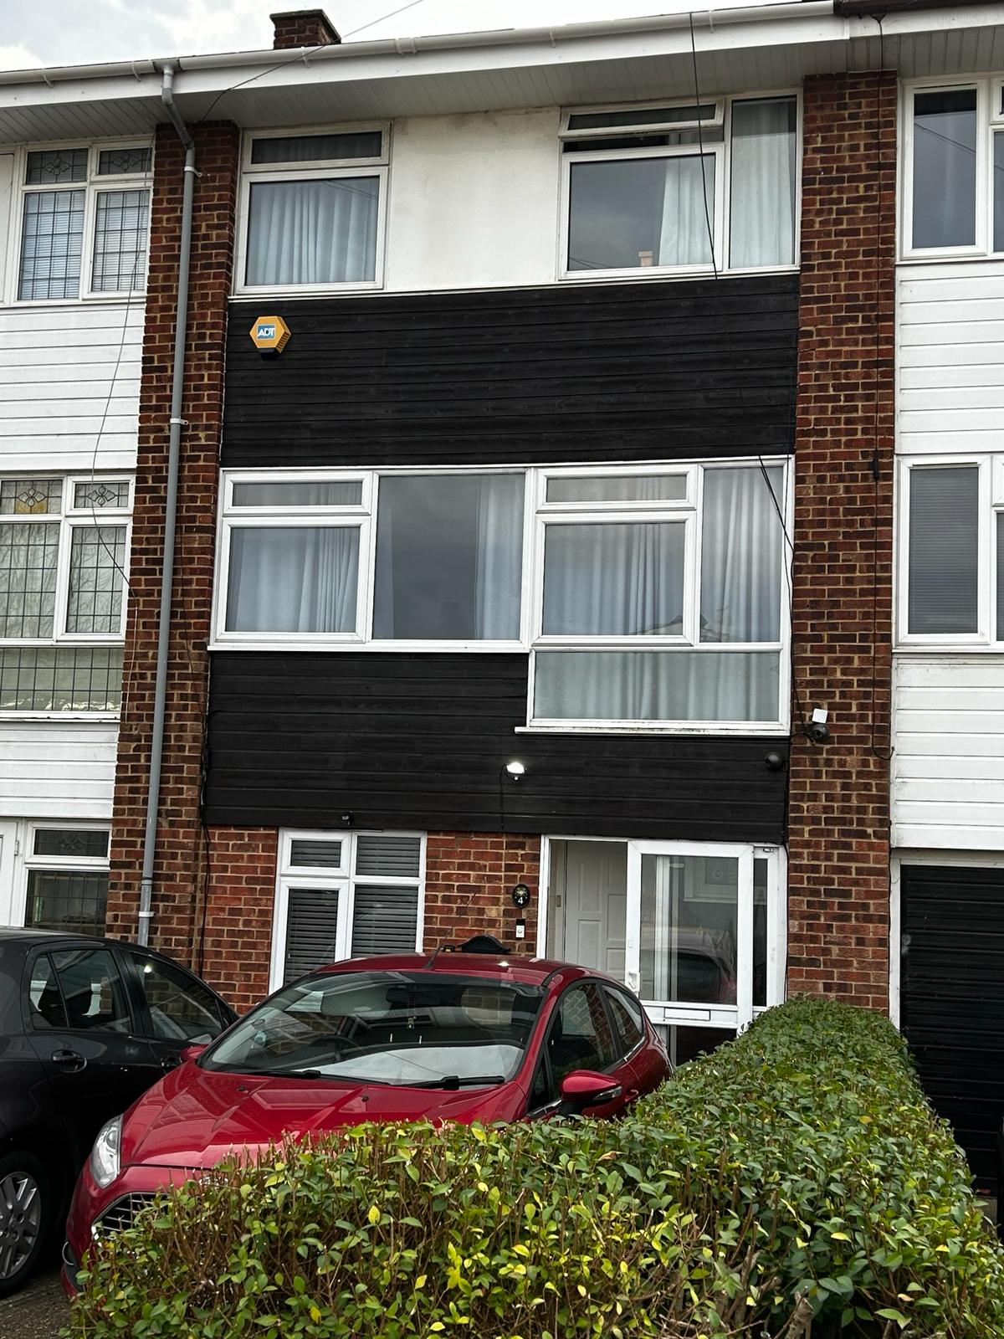

1. Local Area Resources

2. Local Risk Assessment

Our commitment is to locate our unit in a safe, secure, and apt environment. By analysing the pros and cons of the location, we aim to ascertain its suitability to house the service users, where their safety is a priority, and they can avail high-quality services.

The purpose of these location assessments is to ensure that our service users are well protected from potential threats and have access to the required services as detailed in their support plans.

**1.Local Area Resources**

Claygate Close in Hornchurch is in the London region of England. The postcode is within the Elm Park ward/electoral division, which is in the constituency of Dagenham and Rainham.

Claygate Close has been given the Unique Street Reference Number of 21300288 in the National Street Gazetteer.

Claygate Close is located within the county of Greater London, situated in the London region of the UK. It's 13.32 miles East from central London., 17.62 miles Southwest from Chelmsford, 23.9 miles Northwest from Maidstone and 26.66 miles South East from St Albans.

**Socio Demographics**

In Havering, the population size has increased by 10.4%, from around 237,200 in 2011 to 262,000 in 2021.

Between the last two censuses, the average (median) age of Havering decreased by one year, from 40 to 39 years of age.

In 2021, 10.7% of Havering residents identified their ethnic group within the "Asian, Asian British or Asian Welsh" category, up from 4.9% in 2011. The 5.9 percentage-point change was the largest increase among high-level ethnic groups in this area.

Across London, the percentage of people from the "Asian, Asian British or Asian Welsh" ethnic group increased from 18.5% to 20.7%, while across England the percentage increased from 7.8% to 9.6%.

In 2021, 75.3% of people in Havering identified their ethnic group within the "White" category (compared with 87.7% in 2011), while 8.2% identified their ethnic group within the "Black, Black British, Black Welsh, Caribbean or African" category (compared with 4.8% the previous decade).

The percentage of people who identified their ethnic group within the "Mixed or Multiple" category increased from 2.1% in 2011 to 3.7% in 2021.

Education Resources and Performance

In Havering 56% of working age adults have ‘A’ level or higher qualifications compared with 71% for London and 61% for the country as a whole.

Some schools fairly close to Claygate Close are:

Hornchurch High School

Broadstone Road, RM12 4AJ

Tel: 01708691441

www.hornchurchhigh.com

Abbs Cross Academy and Arts College

Abbs Cross Lane, RM12 4YB

Tel: 01708440304

www.abbscross.net

Brook Sixth Form and Academy

Yew Tree Avenue, RM10 7FN

Transport

Train stations in the area:

Romford

1.8 Miles from Claygate Close

Emerson Park

1.8 miles from Claygate Close

Upminster

2.7 miles from Claygate Close

Closest bus stop:

Carfax Road Elm Park

Bus(es): 252 to Collier Row or Hornchurch

Distance: 0.1 miles

Leisure Activities

There are many parks fairly close to Claygate Close. The closest is Harrow Lodge Park (0.6 miles); this park has a lot of green space, a few playgrounds, sports facilities, a lake and a café.

Other attractions in the area include:

Havering Museum

19-21 High St, Romford RM1 1JU

Tel: 01708766571

http://www.haveringmuseum.org.uk/

Oxygen Romford (formerly Jump Evolution)

Spilsby Rd, Harold Hill, Romford RM3 8SB

Tel: 02080501315

https://oxygenfreejumping.co.uk/activity

parks/romford/?utm_source=google&utm_medium=seo&utm_campaign=gmb

Harrow Lodge Leisure Centre

Hornchurch Rd, Hornchurch RM11 1JU

Tel: 01708454135

https://www.everyoneactive.com/centre/harrow-lodge-leisure-centre/

Health Services

There are several health facilities near Claygate Close, such as sexual health clinics, pharmacies, hospitals and general practitioners. Some are listed below:

Sexual & Reproductive Health Community Services In Barking, Dagenham & Redbridge Outpatient East, Hospital, Upney Ln, Barking IG11 9LX

Tel: 02089705724

https://www.bhrhospitals.nhs.uk/sexual-health

Maylands Pharmacy & Travel Clinic

300 Upper Rainham Rd, Hornchurch RM12 4EQ

Tel: 01708453035

http://www.maylandspharmacy.com/

Dr. Poolo's Surgery - Rush Green Medical Centre (GP practice)

261 Dagenham Rd, Dagenham, Romford RM7 0XR

Tel: 01708209220

http://www.dpsrgmc.co.uk/

Queen's Hospital

Rom Valley Way, Romford RM7 0AG

Tel: 03304004333

https://www.bhrhospitals.nhs.uk/

Child & Adolescent Mental Health Service

306 London Rd, Romford RM7 9NH

Tel: 03003001888

Places of Worship

Holy Cross Romford

260 Hornchurch Rd, Hornchurch RM11 1PX

Tel: 07860119450

Havering Islamic Cultural Centre

91 Waterloo Rd, Romford RM7 0AA

Tel: 01708741333

Romford and District Affiliated Synagogue

25 Eastern Rd, Romford RM1 3NH

Shopping Facilities

Sainsbury’s

101-105 High St, Hornchurch RM11 1TX

Costcutter Hornchurch

181 High St, Hornchurch RM11 3XS

Council Facilities

Citizens Advice Havering

Central Library First Floor, St Edwards Way, Romford RM1 3AR Tel: 03003302179

Romford Jobcentre

Crown House, 30 Main Rd, Romford RM1 3HH

Tel: 08001690190

<http://www.gov.uk/contact-jobcentre-plus>

**2.Local Risk Assessment**

Crime Breakdown

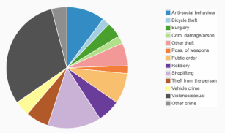I

It appears that in 2022, Havering was indeed one of the safer boroughs in London, with a relatively low crime rate compared to both the London and national averages. The crime rate in Havering was reported to be 74 crimes per 1,000 people, which was 23% lower than the London average of 95 per 1,000 and 7% lower than the national average of 79.5 per 1,000.Despite the lower crime rate compared to averages, there were still a significant number of crimes reported in Havering in 2022, totalling 19,087 incidents. This indicates that while the borough may be safer than others, it still faces its share of criminal activity.

49 crimes in December 2023 within half a mile of the centre of RM12 4LU.

From the chart it can be seen that the majority of crimes committed were either violent/sexual or shoplifting. The least common were crimes such as bicycle theft, possession of weapons and criminal damage & arson.

Gang Affiliation

According to the council’s crime and disorder reduction manager, Havering is not much of a gang borough. In fact, it is known as the 8th safest borough in London. Gang activity is more common in the Romford area, which is close by. However, moped gangs have also been known to pass through Havering.

Missing Person and CSE Support

Concerns should be reported by calling 101 (999 in an emergency)

Some missing person and CSE support organisations operating in Havering are listed below: Runaway Helpline

The Runaway Helpline has been supporting young people for many years and is run by the UK charity Missing People.

Contact: Freephone 116000, TXT 116000 or Email: 116000@runawayhelpline.org.uk.

Safer London Foundation and NSPCC are collaborating on a new project supporting children aged 11-18 going missing and/or at risk of Child Sexual Exploitation (CSE), with NSPCC offering return home interviews and Safer London Foundation following this up by supporting these young people for approximately six months on a weekly basis and referring them when needed.

Sessions are designed to discuss with the young people the reasons behind their disappearance. SLF will also provide consultancy services to professionals and families of missing or at risk of children.

Child Sexual Abuse

Child exploitation is child abuse. If you suspect that a young person is a victim or is at risk of child exploitation, you must get professional help.

Barnado's on 0121 3595333

ChildLine on 0800 1111

NSPCC Helpline on 0808 800 5000

Prostitution

Havering isn’t one of London’s “hotspots” for prostitution, however, brothels have been reported in the area.

The LEA Project

The LEA Project (London Exiting Advocacy) works with women in prostitution anywhere in London. It provides a non-judgemental service giving advocacy and support in exiting.

They provide sessions on:

• one-to-one exit planning

• accessing a range of workshops

• welfare benefits and housing advice

• education, training, volunteering and employment advice

• accessing health services

• accessing drug and alcohol services

The LEA Project supports women to access a range of opportunities and runs a night time outreach service.

Accessing the service

Open to women over the age of 18, working, living or in prostitution in London. Women can contact themselves or be referred to LEA by an agency.

If a young person wants to talk to someone about exiting, call on 020 7683 1270 or email at lea@niaendingviolence.org.uk

The LEA project started in 2010. LEA supports and advocates for women who want help to get out of prostitution. They see prostitution as a form of violence against women and girls. The criteria for our Ascent funded service is any woman is being sexually exploited, and women who are experiencing any form of violence and using substances problematically.

Under the Ascent funded service they will provide support for up to 3 months.

You can contact Lesley directly by phone or send an email with referral form to ascent@niaendingviolence.org.uk.

Pollution

The AQI averages at around 16 and the unit is not located on the main road so there is very little direct contact with pollution from cars.

Nearest Police Building

Dagenham Police Station

561 Rainham Rd S, London RM10 7TU

https://www.met.police.uk/

Havering General Reputation

Havering Borough is generally reputed for its suburban feel, offering a mix of urban and rural areas. It's known for its good schools, parks, and relatively affordable housing compared to central London. However, opinions may vary on aspects like transport links and nightlife options.

Claygate Close (MAP)

